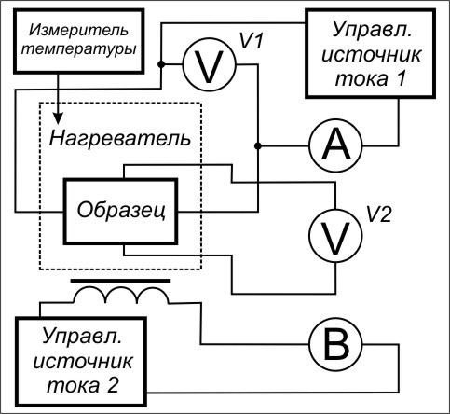
Образец | Образец 1
Длина, мм | 1
Ширина, мм | 1
Толщина, мм | 0,3

Temp = 26,32 °C | g [(ohm*m)-1]
Tok [мA] | p [ohm*m]
B [T] | r [ohm]
U [В] | n(p) [kjh]
EDS [мВ] | Rx [hg]

Tok | B | U | EDS | g | p | r | n(p) | Rx
1,016 | 0,07627 | 1,787 | 9,161 | 1,895 | 0,5276 | 1,759 | 1,762E17 | 35,47
1,017 | 0,03344 | 1,793 | 4,148 | 1,89 | 0,5292 | 1,764 | 1,708E17 | 36,6
1,018 | 0,06204 | 1,789 | 7,514 | 1,896 | 0,5274 | 1,758 | 1,75E17 | 35,71
1,018 | 0,1041 | 1,785 | 12,31 | 1,901 | 0,5259 | 1,753 | 1,793E17 | 34,85
1,018 | 0,09059 | 1,785 | 10,48 | 1,901 | 0,526 | 1,753 | 1,834E17 | 34,08
1,019 | 0,03347 | 1,797 | 4,197 | 1,89 | 0,5291 | 1,764 | 1,692E17 | 36,94
1,021 | 0,01921 | 1,798 | 2,867 | 1,892 | 0,5284 | 1,761 | 1,425E17 | 43,87
1,022 | 0,04787 | 1,797 | 5,798 | 1,897 | 0,5272 | 1,757 | 1,758E17 | 35,55
2,012 | 0,1043 | 3,588 | 24,45 | 1,87 | 0,5349 | 1,783 | 1,788E17 | 34,95
2,013 | 0,09057 | 3,586 | 21,45 | 1,871 | 0,5344 | 1,781 | 1,771E17 | 35,29
2,015 | 0,06214 | 3,587 | 15,06 | 1,872 | 0,5342 | 1,781 | 1,732E17 | 36,08
2,015 | 0,0478 | 3,589 | 11,99 | 1,871 | 0,5344 | 1,781 | 1,674E17 | 37,34
2,017 | 0,03344 | 3,594 | 8,656 | 1,87 | 0,5347 | 1,782 | 1,623E17 | 38,51
2,017 | 0,07649 | 3,593 | 18,24 | 1,871 | 0,5345 | 1,782 | 1,762E17 | 35,48
2,018 | 0,01925 | 3,594 | 5,427 | 1,871 | 0,5344 | 1,781 | 1,491E17 | 41,91

Rx = d.EDS*o.Tolsh/(d.Tok*d.B) [hg]
n(p) = 1/(1.6E-19*[Rx]) [kjh]
r = d.U/d.Tok [ohm]
p = [r]*o.Shir*o.Tolsh/o.Dlina [ohm*m]
g = 1/[p] [(ohm*m)-1]
Eg = –2*k/q*tg(угла наклона) = -0,07453 эВ

