0 | 0
20 | 9
40 | 15
60 | 16
80 | 16
100 | 16
120 | 15
140 | 15
160 | 9
180 | 0
200 | 9
220 | 15
240 | 15
260 | 15
280 | 15
300 | 15
320 | 15
340 | 9
360 | 0

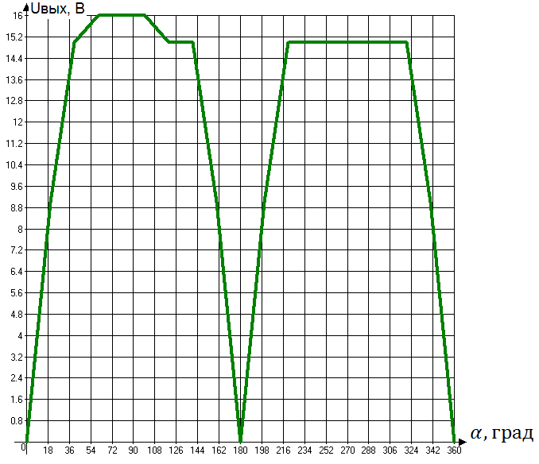
0 | 0 | 0
20 | -0.2 | -0.09
40 | -0.4 | -0.15
60 | -0.5 | -0.15
80 | -0.5 | -0.15
100 | -0.5 | -0.15
120 | -0.5 | -0.15
140 | -0.4 | -0.15
160 | -0.2 | -0.05
180 | 0 | 0
200 | 0.3 | 0.06
220 | 0.4 | 0.15
240 | 0.5 | 0.15
260 | 0.5 | 0.15
280 | 0.5 | 0.15
300 | 0.5 | 0.15
320 | 0.4 | 0.15
340 | 0.2 | 0.05
360 | 0 | 0


